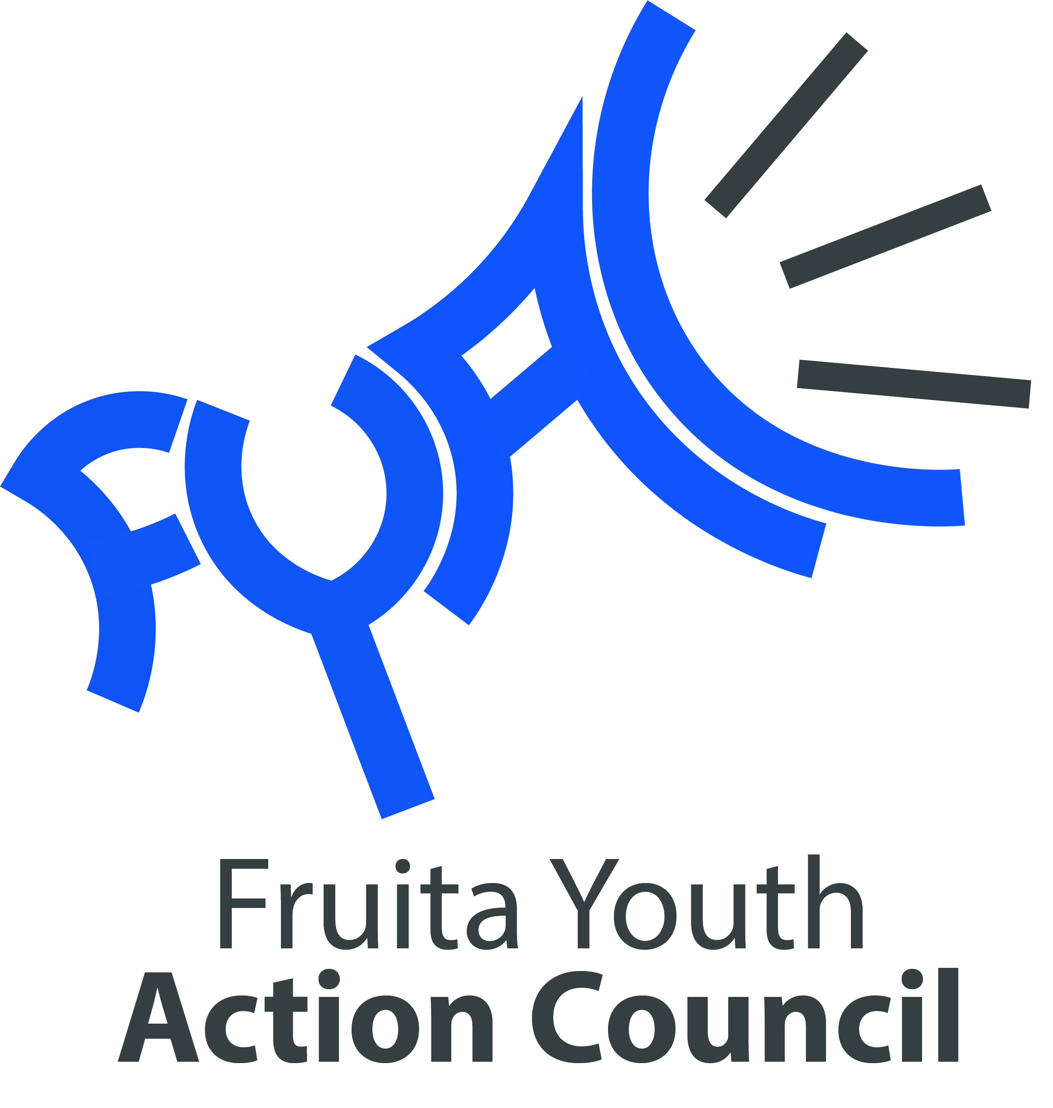

Bylaws of the Fruita Youth Action Council (FYAC)
Content:
- Purpose

- Membership and Roles of the Fruita Youth Action Council
  - FYAC Facilitator
  - Fruita Youth Initiative (FYI) Liaison
  - Committee Leads

- Meeting Guidelines
  - Attendance
  - Equal Voice

- Progress Management
  - Decision Making / Voting
  - Issue Resolution
  - Amendments to Bylaws
- Media Release
- Agreement

Article I. Purpose
Vision Statement for Fruita Youth Initiative:
A caring community that recognizes the value and potential of youth by creating positive opportunities that promotes healthy lifestyles.
Purpose:
The Fruita Youth Action Council is established to serve in an advisory capacity and to make recommendations to the Fruita Youth Initiative (FYI) & City Council on the following matters:
- Youth related issues and relevant topics
- The programs, provided to youth by Fruita Parks and Recreation
- Youth leadership and civic participation
- Opportunities for prosocial activities for youth in the community
The Fruita Youth Action Council also creates an opportunity to put the Positive Youth Development philosophy into action within the City of Fruita by:
- Providing skills and opportunities
- Creating a way to work with youth as partners
- Allowing young people to identify additional opportunities in the community for youth to be a valued partner in community work
- Consulting and involving youth in the Fruita Youth Initiative’s program planning, implementation, and evaluation
- Supporting youth and adult partnership together and sharing power to influence and make decisions regarding the City of Fruita’s programs, services, and opportunities
- Allowing youth to foster connections and build strong relationships with adults and the community and develop a sense of belonging
- Creating intentional, strong connections with other community partners
- Preparing youth for real world situations and future careers
- Valuing youth as an expert and their time and leadership contributions

Article II. Membership and Roles of the Fruita Youth Action Council
- The FYAC consists of up to 20 voting members appointed by the Fruita Youth Initiative board and members of the previous year’s Fruita Youth Action Council. An application and interview process will take place every April to select members for the next year.
- The term of office for each member on the council is one year. Vacancies on FYAC shall be filled for the unexpired term of the vacant position by FYI appointment as soon as possible after the vacancy occurs.
- Fruita Youth Initiative has the sole discretion to appoint new FYAC members of its choosing in the event of a vacancy. FYAC may in its discretion recommend alternates to FYI for appointment to FYAC in the event of a vacancy and may recruit and recommend nominees to the Fruita Youth Initiative.
- Each nominee shall have been a resident of the City of Fruita and/or attend a school located in the Fruita area for at least one year immediately prior to the day of his/her appointment.
- President, Vice President & Secretary positions will be elected by the September monthly meeting. Nominations will be taken in last August. These positions are going to need to commit to the role and attend all monthly meetings as well as other required meetings/events. These positions will be role models for their peers in FYAC as well as outside of FYAC.

FYAC Facilitator

The FYAC Facilitator will be the City of Fruita Youth Activities Supervisor and is a non-voting liaison that provides the following support and assistance to FYAC, additional duties are subject to approval by Fruita Youth Initiative based on budget and available resources:
- Ensure the agenda is prepared for scheduled meetings
- Provide notice of meetings in a manner that is effective for communication in the group (GroupMe App, email, text, etc.). FYAC will identify the best method of communication to the group upon appointment on FYAC
- Ensure that minutes are taken and kept for reference for all members
- Assist the Fruita Youth Action Council during all meetings and community outreach and engagement
- Ensure that actions and activities of the FYAC are consistent with the policies and procedures of the City of Fruita
- Offer insights about City of Fruita organization policies and efforts
- Notify the FYAC of events, meetings, or circumstances when the FYAC Facilitator is asked to speak on behalf of the Fruita Youth Action Council
- Assist in filling of vacancies
- Act as point person for contact with other City of Fruita liaisons, departments, or boards unless otherwise delegated
- Facilitate communication among members
- May participate in all discussions but is not a voting member
- Presents the FYAC position without bias
- Monitor and direct projects identified by the Fruita Youth Action Council to ensure compliance with established goals

Fruita Youth Initiative (FYI) Liaison:
There shall be one FYI liaison that serve one year terms. The liaisons shall update the Fruita Youth Action Council on meetings taking place within the Fruita Youth Initiative and shall represent FYAC and their viewpoints and feedback at FYI meetings. When liaisons are absent, the members present shall select a member to represent FYAC at FYI meetings by consensus or by a majority vote.

Fruita Youth Action Council Standing Committees:

Each Committee will consist of members of the Fruita Youth Action Council who have volunteered to serve on the specific committee. The Committee will vote for a Chairperson. Each Committee will forward their task accomplishments to the Chairperson to report back to the FYAC facilitator and FYAC at each regular meeting.

Elections

Each committee chairperson shall be elected by the FYAC every August. Nominations for a chairperson position do not require a second. Nominees shall have an opportunity to speak to their nomination before the vote is taken. A voice vote shall be taken to elect all chairpersons(President, Vice President & Secretary). A chairperson shall be elected by a majority of the members present.

Vacancies of a Chairperson

A vacancy in a committee chair position shall be filled by election at the next regular or special meeting of the FYAC from among the members. All chairpersons elected to fill a vacant officer chair position shall serve until the next election.

Community Outreach Committee

The Community Outreach Committee will be available to represent Fruita Youth Action Council at City Council Meetings, City of Fruita Events, or other community engagements as they are identified to educate community members on the work FYAC is doing, identify opportunities for youth involvement, and advocate for youth in the Fruita area. This committee will also participate in giving feedback on community initiatives to improve effectiveness of youth outreach efforts.

Communications Committee

The Communications Committee will work with the FYAC facilitator to contribute to outreach to television, newspaper, radio, and regular social media feeds. The Committee members will also work with Fruita Youth Initiative to implement a strategy to change social norms by using mass media campaigns to post relevant information on social media.

Special Committees

Special committees may be authorized and formed for special limited purposes and to work on specific issues or projects as needed. A special committee shall serve only until completion of the special limited purpose for which it was created by Fruita Youth Action Council. Recommendations of a special committee must be approved by FYAC before being considered officially adopted.

Article III. Meeting Guidelines

FYAC Meetings

The Fruita Youth Action Council will meet monthly on the second Monday of each month at 6:30 pm at the Fruita Community Center. Due to scheduling conflicts, sometimes the meeting may be moved to the first or third Monday (this may only happen once or twice).

The monthly Fruita Youth Action Council meeting will allow for coordination of FYAC activities, informing members of progress and work of committees, participating in decision making with the City of Fruita, FYI or other community partners when needed and assisting with community efforts to engage youth.

The FYAC Facilitator and the FYAC Officers (President, Vice President & Secretary) will be responsible for facilitating the meeting, keeping members focused on the discussion at hand and remind members of the meeting’s purpose and time frame.

The Secretary will be identified during each regular meeting and is responsible for the minutes of the meeting and will provide minutes to the FYAC Facilitator. The Facilitator will then forward the minutes to the Fruita Youth Initiative.

For the school year 2023/2024, we will develop two mini groups within FYAC. These are the Community Events and the Social Media/Communications groups. These groups will also meet outside of the monthly meeting and the meetings will more than likely occur every two weeks with these groups. Any member of FYAC is able to be in either or both groups, however, it is not a requirement to be in either of them. It is asked that if you do join one or both mini groups that you be at most of the meetings and actively participate.

Meeting Norms
These norms will describe the practices which will apply to any meeting that takes place for the Fruita Youth Action Council:

- We will respect everyone’s time by starting and ending on time.
- Only one conversation at one time.
- Capture off topic items in the minutes and agree to discuss them later at a more appropriate time.
- Be present with the people you are meeting with. Put away phones and other devices during the meeting.
- Everyone is responsible for helping to stay on topic. Speak up if you feel like we’re getting off track.
- Treat all members with respect
- Everyone is responsible for upholding the norms. Acknowledge if you notice we are not doing so.

Attendance

Any member who has absences from three regular meetings in a six month period shall receive written notification from the Fruita Youth Action Council Officers advising the member of his/her absences. Any member who has absences from four regular meetings in a six month period or misses three consecutive regular meetings shall be subject to dismissal as a member of the Fruita Youth Action Council by the Fruita Youth Initiative. The FYAC Facilitator shall be notified of any member of the Committee who has absences from four meetings in a six month period and or any member who is absent from three regular consecutive meetings.

Fruita Youth Action Council Members who miss two consecutive meetings will be contacted and encouraged to increase their involvement/attendance. If the member misses two additional meetings (total of 4), the member will be removed from FYAC unless such absences were the result of a personal crisis and found to be excused by either the FYAC Facilitator or FYAC Elected Positions.

Equal Voice

It is critical that all members of the Fruita Youth Action Council are valued and have the chance to be heard. Any one member of the council should not monopolize meetings so that everyone has a chance to participate and offer their ideas. It will be the Chairperson’s responsibility to ensure no one person monopolizes a committee meeting and all members have the opportunity to share their thoughts or ideas.

Article IV. Progress Management
Decision Making and Voting

A quorum will be established if greater than 50% of active members are present for the meeting or involved in the discussion/decision on a specific topic via email or electronic communication. This will be applicable for Fruita Youth Action Council and Committee meetings. A vote will not occur unless a quorum is achieved. Members can vote on a decision in person or via email or other application such as GroupMe.

In the event of a tie vote within a committee meeting, the Facilitator will make the final decision. If a tie occurs during a Fruita Youth Action Council Meeting and cannot be resolved, the vote shall be brought before the Facilitators for a vote. In the event of a tie vote, the council should attempt to solve the issue first by a discussion, and then a second vote. Active members are any members who have not missed two or more consecutive meetings.

Issue Resolution
If there is an issue that arises during a committee meeting, the group should first attempt to resolve the issue. If there is no resolution, the Facilitator will be responsible for bringing the issue before the Fruita Youth Action Council. If the Fruita Youth Action Council is not able to resolve the issue, the issue will be brought before the Fruita Youth Initiative. The Fruita Youth Initiative will have the final authority to resolve an issue.

Amendments to Bylaws

Amendments to these Bylaws shall be reviewed as needed and proposed amendments shall be approved by an affirmative vote of no less than a majority of the total current members of the Fruita Youth Action Council. Copies of the proposed amendments shall be provided to each member of the council at least one 1 week prior to the date of any regular or special meeting at which the bylaws amendments are on the agenda for consideration. All amendments to these Bylaws are subject to review and approval by Fruita Youth Initiative.

Article IV. Media Release
Media Release

By participating in the Fruita Youth Action Council, members authorize and consent to the publication of themselves whether by television, newsprint, written, online advertisements or otherwise, of any materials contained in their name or picture for participation in any event or meeting associated with the Fruita Youth Action Council.

Article V. Agreement
I consent to, and hereby do, adopt the foregoing Bylaws, consisting of the ten preceding pages, as the Bylaws of the Fruita Youth Action.

Date: August 24, 2024

Name:

Signature:

Parent’s Name:

Parent’s Signature:

